|  |  |  |
| --- | --- | --- |
|  | | |
| **Welcome to ‘The Pulse’** | **The Pulse**  “The heart of God  to the heart of the community”  **March 2018 Issue** |

The Pulse is newsletter produced by the Ellesmere Cooperating Parish. We are three congregations that make up a rural parish in the south-eastern part of the Selwyn District of Canterbury, NZ.

Our congregations gather folk from Leeston, Southbridge, Dunsandel and Brookside, drawing people from all walks of life, with a high proportion involved in farming or associated services. Our main worship centres are at St. David’s, Leeston and Trinity, Dunsandel. Our Brookside congregation has shared use of St. Luke's Anglican Church at Brookside.

**Purpose Statement:** To spread the good news of Jesus by committing ourselves to work and worship together, to love and care for one another, and to be of value to God in our community.

To find out more about the Ellesmere Cooperating Parish, please take the time to visit us on line at [www.churchatellesmere.org.nz](http://www.churchatellesmere.org.nz/)

We hope you enjoy this issue of The Pulse.

Your newsletter was delivered by:

…………………………………………………………….

Phone: …………………………..............................

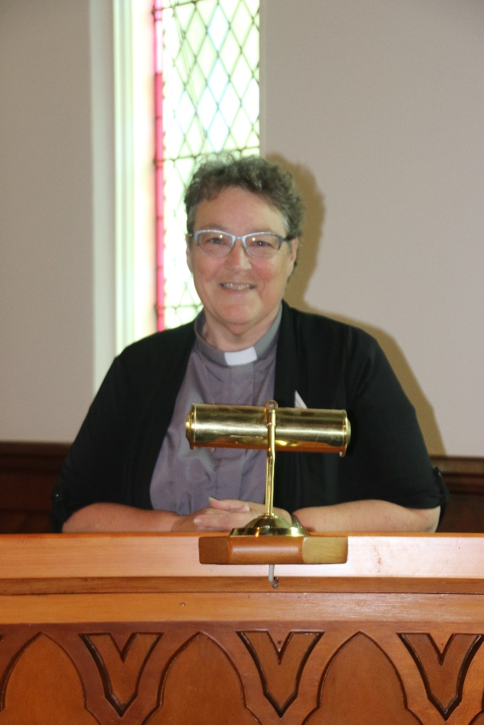**Reflection from Rev. Heather Kennedy**

As I write this just after our Ash Wednesday service, I thought that it might be helpful to share an explanation of what the season of Lent is all about.

Lent is a season of forty days, not counting Sundays, which begins on Ash Wednesday and ends on Holy Saturday, the day between Good Friday and Easter Day. Lent comes from the Anglo-Saxon word ‘lencten’, which means "spring." The forty days represents the time Jesus spent in the wilderness, enduring the temptation of Satan and preparing to begin his ministry.

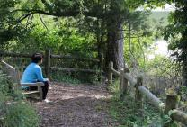Lent is a time of repentance, fasting and preparation for the coming of Easter. It is a time of self-examination and reflection. In the early church, Lent was a time to prepare new converts for baptism. Today, Christians focus on their relationship with God, often choosing to give up something or to volunteer and give of themselves for others.

Sundays in Lent are not counted in the forty days because each Sunday represents a "mini-Easter" and the reverent spirit of Lent is tempered with joyful anticipation of the Resurrection.

**Parish Council Report from Rev. Heather Kennedy – January 2018**

To begin this report, I would like to say how much I enjoyed the myriad of celebrations, gatherings, social occasions and Christmas services through December. The sense that Christ’s birth is important for our expression of faith was effectively borne out through the seasons of Advent and Christmas. Those that helped with the sausage sizzle on the night of the Leeston Christmas Parade did very well, and having the church open with music and graphics displayed, saw a steady trickle of people passing through and visiting the church. It was good to chat with these folks.

We celebrated the final Home Group meeting at Ruth Cridge’s home in Southbridge in December, with her now happily settled at Abbeyfield. Home group meetings at Bev Gilbert’s will commence on the first Tuesday in March.

The time and talent put into the children’s presentations at St. David’s and Trinity were greatly appreciated by all who attended. I also enjoyed singing along with the Selwyn Singers. I have posted some of the photos I took of these events on the parish website.

I provided a Communion service at Ellesmere Hospital for some residents, family and friends, just before Christmas. As well as that, there were the extra services for Christmas Eve and Christmas and all the lovely fellowship enjoyed by all for those occasions.

Jim and I enjoyed the time we had away after New Year’s Day and made the most of opportunities to catch up with our North Island family and friends, as well as enjoying the warm weather and some hot and ‘not-so-hot’ swims.

It has been encouraging to see so many attending worship services for the combined services for New Year’s Eve and January. I am looking forward to the events of this year and all that we are going to be involved in prior to the end of my employment contract.

The Pastoral Care committee have practically completed the process of contacting those who were sent the ‘Count Me In’ forms and have contacted most of those who had not responded. We have concluded that 126 parishioners have indicated that they are members, we will welcome 6 ‘new’ these at the Covenant Sunday services. Of those contacted, 40 have indicated that they do not consider themselves members but are willing to continue being connected with the parish by receiving The Pulse and are happy to receive pastoral care if this is required. There are 24 children in total who are connected with the parish. The number of Pulses to print each time and how many people we need to deliver them, had dropped by 50 copies.

We are still looking into the requirements of up-grading the parishes technology requirements and is heading towards downloading some soft-ware updates for the laptops next month.

The team working on the Parish Profile is working well, so they hope to circulate for comment some of the material they produce, in due time, so that we can then fulfil all the requirements of the Methodist Stationing process.

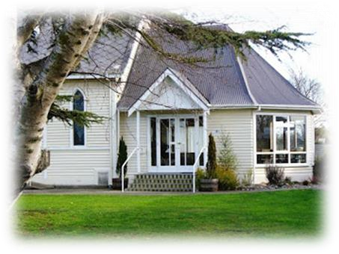***News from the Leeston Sector Group***

***-from Frances Baylis***

*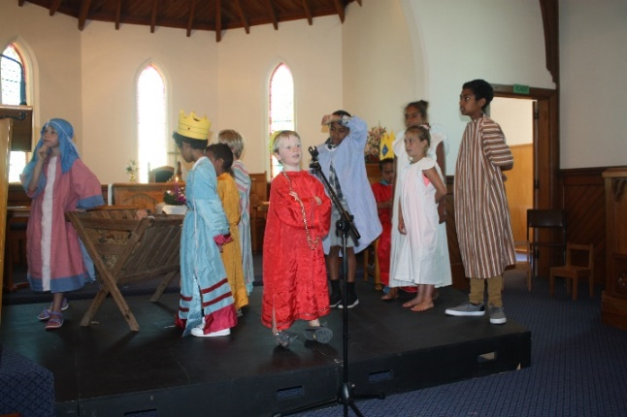Firstly, the children’s Christmas presentation was a wonderful interpretation of the story of Jesus’s birth, I would like to commend all the children on how well they acted their parts. I’m sure the congregation enjoyed watching the children. Thank you to the adults who helped.*

*Thank you to those who helped me with the sausage sizzle the night of*

*the Christmas Parade with $190.00 added to the building fund.*

*There was a feeling of warmth at the services combined with the*

*Anglicans in January.*

*We are pleased to report that the organ previously from the Southbridge Presbyterian Church has now been moved to Abbeyfield after being careful housed in Ruth’s home for ten years.*

*I would like to thank Kathy for painting the toilets at St David’s*

*which now makes them look very respectable. Kathy has also organised a new sign for the Mission Shed.*

*I am working towards repairing and reinstating the marble font into the church.The children’s program is up and running for Term One.*

*Please look out for new roster lists and if you are able to help with any*

*of the duties to make us ready for worship please let me know.*

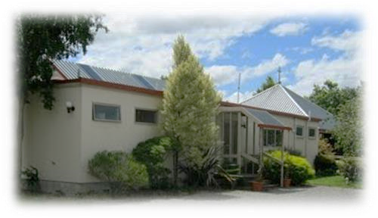***News from Dunsandel Sector group***

* ***From Jill Chamberlain***

*In November the kitchen at Trinity benefitted from the addition of a new (to us) fridge. Thanks to Roger and Jeanette Doak for making this possible.*

*On the 28th November a successful outdoor working bee was held and the grounds looked better after a general tidy up. Morning tea was a highlight. Athol Wolff has been doing a great job keeping the lawns under check. An indoor working bee was held on the 29th January and a good start was made on tasks. There will be a follow-up hopefully before Easter.*

*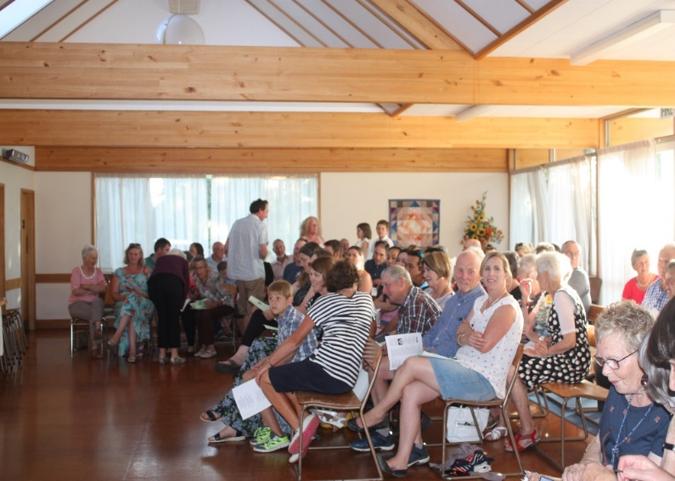The Community Carol night was a week earlier than usual this year on the 11th December. Maybe there was not the atmosphere of Christmas being imminent but soon everybody was enjoying the traditional carols and entertainment. The choir set the mood with “Look Towards Christmas.” The children were excellent with their performance of “The One That Counts.” Don Clearwater gave an entertaining slant on the words of “While shepherds Watched Their Flocks by Night,” and Margaret sang with the children. Gabby and Douglas Michael, as MCs, kept the evening rolling along. As usual the evening concluded with an amazing supper.*

*There was a good turnout for the Christmas Eve service also followed by a traditional Christmas supper.*

*On New Year’s Eve Trinity hosted the combined Anglican/ Cooperating Parish service with Rev. Heather officiating. This set the tone for all of the January services to follow. It is wonderful to see the churches full and join in worship with the district as a whole. Seeing the fellowship as people linger over the morning teas, it is evident that these services are popular.*

*The funerals for Tony Tyson and John Reid were catered for on 9th January and 2nd February respectively. The people of Trinity were complimented on their hospitality in providing a wonderful welcoming atmosphere and abundant, delicious food.*

*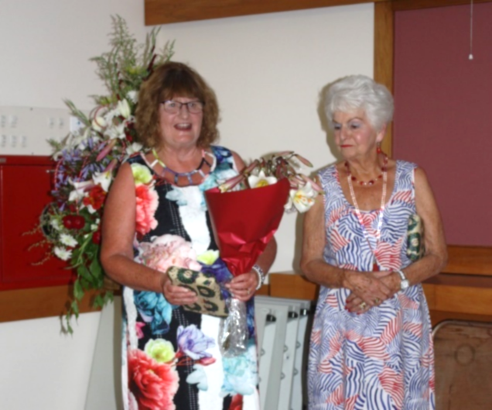We look forward to the joys and challenges of the coming year.*

*Jill is seen here with Mavis Barnett as they are thanked for their involvement in the Community Carol Service at Dunsandel.*

**Hugs**

Sometimes its nice to get an unexpected hug

for no other reason than just because you are loved and cared for.

So while your are reading these words,

don’t think of them as just words…

Think of each one as a hug for your heart from mine!

* Barbara J. Hall (supplied)

A Hug takes all the nicest feelings – love, friendship, happiness and appreciation – and wraps them up in one beautiful package. A hug is warmth and comfort for the sad days, a sharing of smiles for the happy days, and a special reminder that someone cares for every day in between.



***And now for something funny…*** 

**News from St. David’s Friendship Group.**

Our November meeting was held in St. David’s in the Evening, when Hilary Boal welcomed Don (Heslop) who with his commentary and power point presentation took us on his recent overseas tour. His travels this time took him on a River Cruise, beginning in Amsterdam cruising along the Rhine through Austria, Germany and ending on the Danube in Budapest in Hungary. An interesting leisurely journey seeing each Country’s landscape, towns and cities and centuries old architecture. Don ended his trip with a visit to Scotland, where he attended the Edinburgh Tattoo – a memorable event to end an interesting journey.

Our Christmas get-together was a Luncheon Meeting combined with the Afternoon Fellowship Members. It was good to have Jim Kennedy join us too. Our meal was at Cheryl Halls home in Southbridge; it was her usual delicious Roast Meal, with Dessert of berryfruit, icecream and Christmas Pudding to follow. Members brought along their Gifts and Goodies for “ECCO”.

We met at The Manse in February, when Hilary lead the Meeting. Rev. Heather lead Devotions reading Psalm 149 A Hymn of Praise, she also read a passage on Creation from a book written by Sylvia Purdie- Minister at Cashmere Presbyterian Church entitled “Psalms in a Fresh Voice” telling us how through God we can be creative with our own Talents.—Social time followed—“ Bring a favourite Book, Piece of Art or Craft to talk about—what an interesting time we had with all contributing with their special Article/ Creation/Book.

During Afternoon Tea we celebrated Nancy Lowery’s 90th Birthday and including Francie Prosser’s recent 90+ Birthday too, with a Cake complete with Candles to blow out and sing Happy Birthday.

**St. David’s Afternoon Fellowship Report**

On 1st November 2017 the Afternoon Fellowship joined the Friendship Group at St David’s in the evening to hear Don Heslop talked about his latest trip overseas. Don travelled through a number of countries on a boat down rivers between Amsterdam and Slovakia, he as usual gave us an informative talk which was appreciated by all who attended. The evening finished with a lovely supper.

On 6th Dec 2017 a group of ladies meet at St David’s and carpooled to Southbridge, along with Rev. Heather and Jim Kennedy, to enjoy a lovely meal at Sheryl Halls. Gifts and Groceries were donated to be distributed by ECCO to worthy people.

On 8th Feb 2018 Ten members went to visit the new residents of Abbeyfield and after a short meeting we shared a lovely afternoon tea with them. The fellowship members were so generous that the residents would be able to have morning and afternoon tea for several days. It was great to see how well the residents have settled into their new abode. This visit was appreciated and we have been invited back later in the year.

**Southbridge Home Group**

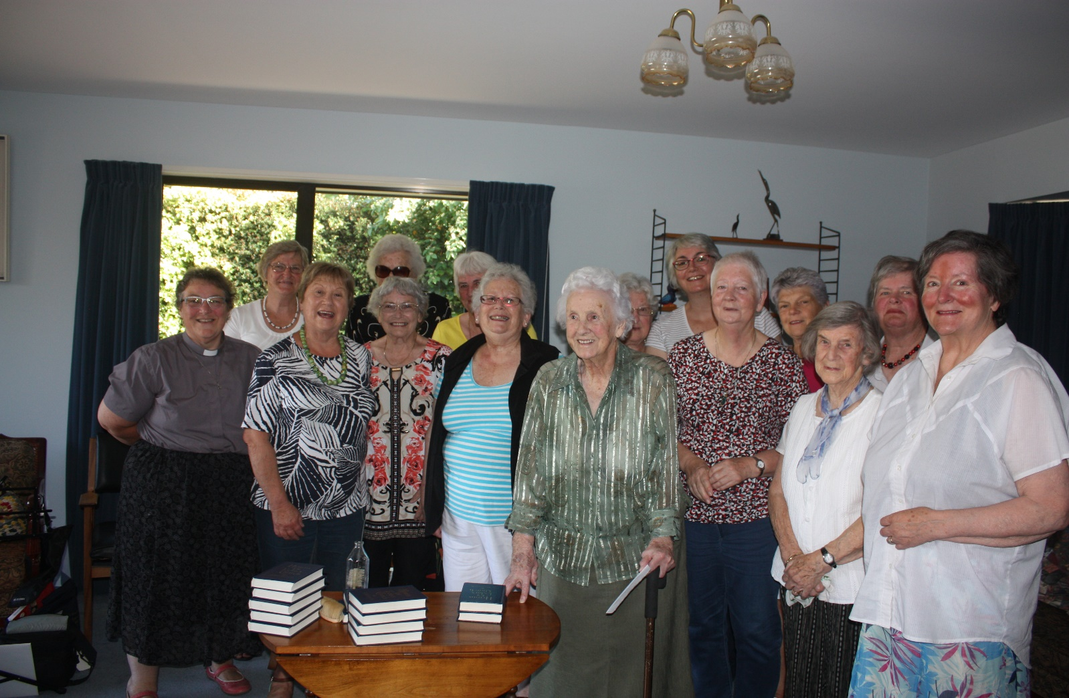

*Those who attended the final Home Group service in December at Ruth Craft’s home in Southbridge. This was followed by morning tea at the Southbridge Café.*

*ELLESMERE COMMUNITY CARE ORGANISATION*

A Big **Thank You** to all those who contributed items of food and gifts under the Christmas Tree at St. David’s. Special thanks to the Friendship Group and the Afternoon Fellowship, and others from our congregation for their generosity. The Christmas Hampers were delivered by Volunteers of ECCO to all parts of the Ellesmere District prior to Christmas – they are received with great joy and excitement by the Families. Each child and adult receives a personal gift along with Christmas goodies and food for the family. This year 38 families including 60 children received parcels, and they made a joyful difference to their Christmas celebration.

Please accept our grateful thanks to all of you who gave so generously. Lois Birkett on behalf of ECCO

‘Change of Lifestyle’

UNIT FOR SALE

30 High St., Leeston

Have you thought of down-sizing while you’re still active and have the energy to do something different?

ST. DAVID’S PLACE has a home waiting for you – to accomplish some of those ‘MUST DO’ adventures.

No lawn to mow, a small garden, friendly neighbours and warm, sunny home that is easy to keep.

We invite you to come and have a look and make an offer to purchase.

Contact: Noel Dalley 03 324 3171

Or John Lay 03 329 1617

**Koha**

Christ is born; the heavens ring, “let the world in every corner sing.

Hear! All Nature rejoice, each with one voice resounding.”

Bring him gifts from near and far, come and lay them beneath his star. So the waking child finds precious gifts of God’s designs.

Aoraki standing proud, high above the brooding white cloud.,

Hear! The dawn chorus cry from floor to sky, ascending:

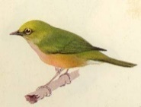Carry voices from afar, come and lay them beneath his star. So the waking child hears Korimako’s gift so clear.

Pohutukawa glowing bright spreads her leaves and flowers to the light. See! Her crisp red bouquets, the crimson rays, descending:

See them carpeting the sand, come and lay them near his hand.

So the waking child sees Tane’s gift of rare beauty.

Haere mai. Haere Mai. - Don Clearwater

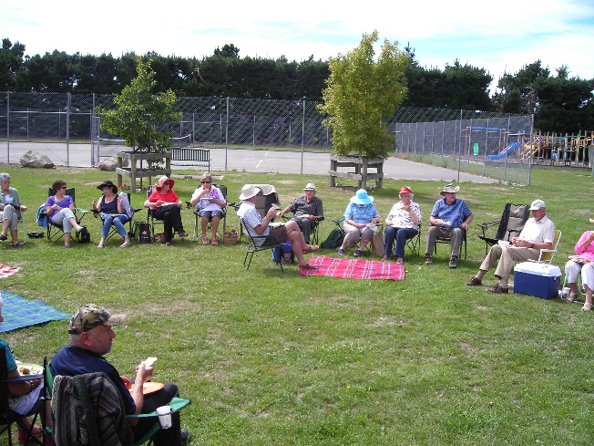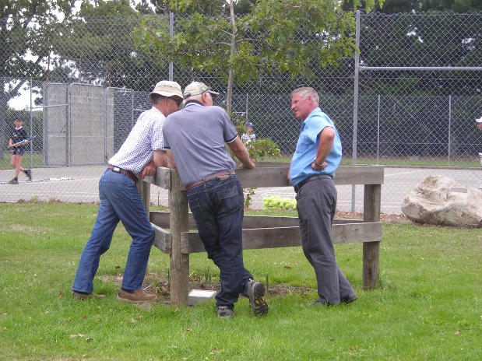

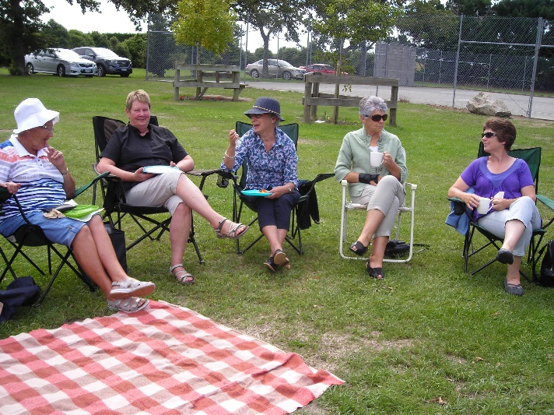

*Scene at the Parish Picnic*

***A page for the children to colour-in***



***Services & Events –***

***March 2018 to May 2018***

|  |  |  |
| --- | --- | --- |
| **March 2018** |  |  |
| Thursday 1 March | 7.00pm | Men’s Fellowship – Leeston Library |
| Saturday 3 March | 7.30pm | Lifetouch Fellowship |
| Sunday 4 March | 9.30am  11.00am  5.00pm  7.30pm | Communion Services – Lent 3  St. David’s, Leeston  Trinity, Dunsandel  Youth Pizza Café – Leeston  Brookside (Anglican) Service |
| Tuesday 6 March | 9.30am | Southbridge Home Group at Bev’s |
| Wednesday 7 March | 2pm | St. David’s Friendship group and Fellowship Groups combined |
| Thursday 8 March | 2.oopm  7.30pm | Trinity Women’s Fellowship  Leeston Sector meeting |
| Saturday 10 Nov | 10.ooam –  3.00pm  7.30pm | Methodist Synod at Trinity, Dunsandel  Lifetouch Fellowship |
| Sunday 11 March | 9.30am  11.00am | Worship Services – Lent 4  St. David’s, Leeston  Trinity, Dunsandel |
| Thursday 15 March | 7.30pm | Dunsandel Sector meeting |
| Saturday 17 Nov | 7.30pm | Lifetouch Fellowship |
| Sunday 18 March | 9.30am  11.00am  7.30pm | Worship Services – Lent 5  St. David’s, Leeston – Harvest Festival  Trinity, Dunsandel (Anglican) - Harvest  Brookside (Communion Service) |
| Thursday 22 March | 7.30pm | Parish Council at Trinity, Dunsandel |
| Saturday 24 Nov | 9.30am  7.30pm | Leeston Feté  Lifetouch Fellowship |
| Sunday 25 March | 9.30am  11.00am | Worship Services – Palm Sunday  St. David’s, Leeston  Café Church, Dunsandel |
| Thursday 29 March | 7.00pm | Passover / Tenebrae service / meal at Trinity, Dunsandel |
| Friday 30 March | 10.00am | Good Friday Community Service,  Anderson Square, Leeston |
| Saturday 31 March | 7.30pm | Lifetouch Fellowship |

|  |  |  |
| --- | --- | --- |
| **April 2018** |  |  |
| Sunday 1 April | 9.30am  11.00am  5.00pm  7.30pm | Communion Services - Easter  St. David’s, Leeston  Trinity, Dunsandel  Youth Pizza Café at St. David’s  Brookside (Anglican) Service – Harvest Festival |
| Tuesday 3 April | 9.30am | Southbridge Home Group |
| Wednesday 4 April | 12.00 noon | St. David’s Friendship and Fellowship groups combined |
| Thursday 5 April | 7.00pm | Men’s Group, Leeston Library |
| Saturday 7 April | 7.30pm | Lifetouch Fellowship |
| Sunday 8 April | 9.30 am  7.30pm | St. David’s, Leeston – Easter 2  Worship Service at Dunsandel and barbeque lunch |
| Thursday 12April | 2.00pm  7.30pm | Trinity Fellowship group  Leeston sector meeting |
| Saturday 14 April | 7.30pm | Rural Ministry International visitors  Lifetouch Fellowship |
| Sunday 15 April | 9.30 am  7.30pm | Worship Services – Easter 3  St. David’s, Leeston  Brookside service |
| Saturday 21 April | 7.30 pm | Lifetouch Fellowship |
| Sunday 22 April | 9.30am  11.00am | Worship Services – Easter 4  St. David’s, Leeston  Café Church, Trinity, Dunsandel |
| Wednesday 25 April | 10.00am | Anzac Day services |
| Thursday 26 April | 7.30pm | Parish Council meeting, Leeston |
| Saturday 28 April | 7.30pm | Lifetouch Fellowship |
| Sunday 29 April | 9.30am | Combined Worship Service – Easter 5  Trinity, Dunsandel |

|  |  |  |
| --- | --- | --- |
| **May 2018** |  |  |
| Wednesday 2 May | 2.00pm | St. David’s Friendship group |
| Thursday 3 May | 7.00pm | Men’s group, Leeston Library |
| Saturday 5 May | 7.30pm | Lifetouch Fellowship |
| Sunday 6 May | 9.30am  11.00am  5.00pm  7.30pm | Communion Services – Easter 6  St. David’s, Leeston  Trinity, Dunsandel  Youth Pizza Café at St. David’s  Brookside (Anglican) |
| Thursday 9 May | 2.oopm  7.30pm | Fellowship groups  Leeston sector meeting |
| Saturday 12 May | 7.30pm | Lifetouch Fellowship |
| Sunday 13 May  (Mother’s Day) | 9.30am  11.00am | Worship Services  St. David’s, Leeston – Easter 7  Trinity, Dunsandel |
| Thursday 17 May | 7.30pm | Dunsandel sector meeting |
| Saturday 19 May | 7.30pm | Lifetouch Fellowship |
| Sunday 20 May | 9.30am  11.00am  7.00pm | Worship Services - Pentecost Sunday  St. David’s, Leeston  Trinity, Dunsandel  Brookside |
| Thursday 24 May | 7.30pm | Parish Council meeting at Brookside |
| Saturday 26 May | 7.30pm | Lifetouch Fellowship |
| Sunday 27 May | 9.30am  10.45am | Worship Services – Trinity Sunday  St. David’s. Leeston  Café Church, Trinity, Dunsandel |

For all events please check for updates or alterations in the Weekly Bulletins as times and dates may change.

**Small Groups for all ages!**

|  |  |  |
| --- | --- | --- |
| **Groups for Adults** | |  |
| **Intercessory Prayer** | 7.00pm | Every Tuesday, at St. David’s, Leeston, note: last Tuesday of month at Trinity Church, Dunsandel.  *Contact Mandy, ph: 324 2225* |
| **Southbridge Home Group** | 9.30am | 1st Tuesday of the month at Bev’s home in Southbridge. *Contact Janice, ph: 324 8202.* |
| **St. David’s Friendship**  **Group** | 2.00pm | 1st Wednesday of the month at various homes.  *Contact Hilary, ph: 324 3823.* |
| **St. David’s**  **Afternoon**  **Fellowship** | 2.00pm | 2nd Thursday of the month at the Church.  *Contact Janice, ph: 324 8202.* |
| **Trinity Women’s**  **Fellowship**  **Group** | 2.00pm | 2nd Thursday of the month at Trinity Church, Dunsandel.  *Contact Mavis ph: 325 4142.* |
| **Lunch Bunch** | 12.00 noon | A Dunsandel Trinity initiative – 1st Thursday of the month at various local eateries. *Contact Mavis ph: 325 4142.* |
| **Men’s Group** | 7.00pm | 1st Thursday of month at Community Room, Leeston Library. |
| **Lifetouch Fellowship** | 7.30pm | Ministry for Filipino families and others.  Worship Service every Saturday. *Contact Teena, ph: 324 2240 or 021 081 62926.* |

|  |  |  |
| --- | --- | --- |
| **Groups for Children & Youth** | | |
| **Children’s**  **Ministry** |  | During worship each Sunday during the school term in Leeston.  *Contact Lois ph: 324 3884* |
| **Pre-school Music** | 9.45am –  10.30am | Wednesdays at St. David’s Church foyer, followed by coffee and chat for parents and caregivers in the church hall.  *Contact Naomi ph: 324 4075.* |
| **Youth Pizza Café** | 5.00pm –  7.00pm | 1st Sunday of the month at St. David’s Church, Leeston.  *Contact Linda ph: 324 2166* |

|  |
| --- |
| **Deadline for next newsletter - 22 May 2018**  **Contact person - Rev. Heather Kennedy**  Please send your information by email to [rev.heather.kennedy@gmail.com](mailto:rev.heather.kennedy@gmail.com) by the deadline date. |

|  |  |
| --- | --- |
| **CONTACT DETAILS** |  |
| **Minister** | **Phone** |
| Rev. Heather Kennedy | 324 3315 |
| **Email** | rev.heather.kennedy@gmail.com |
| **Website** | [www.churchatellesmere.org.nz](http://www.churchatellesmere.org.nz/) |
| **Lifetouch Pastor** |  |
| Teena Dela Cruz | 324 2240 |
| **Senior Laypersons** |  |
| Paul Birkett | 324 3884 |
| Robbie Stewart | 325 4535 |
| **Pastoral Care** |  |
| Lois & Paul | 324 3884 |
| Janice | 324 8202 |
| Robbie | 325 4535 |
| Noel | 329 1877 |